New Leaf Nutrition LLC
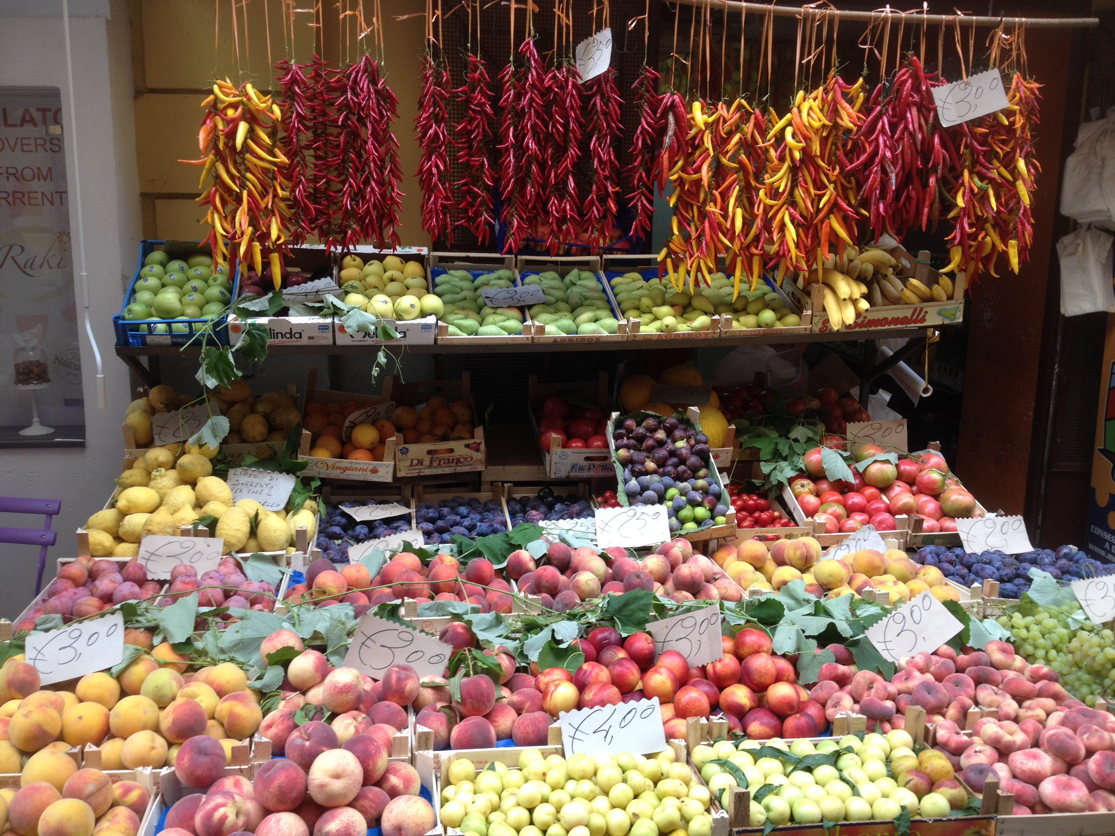
Julia Hincman-Francavilla MS, RD, CSO, LDN
Registered Dietitian
10 Colonial Road
Salem, MA 01970
Newleafnutrition1@gmail.com
617-306-3897

Please send or email this form to newleafnutrition1@gmail.com prior to nutrition appointment if possible. This form will be kept confidential.

Client Name: ________________________________________________________________________________

Date of Birth: ______________________________

Phone number: _______________________________Email: _______________________________________

Address: ______________________________________________________________________________________

Occupation: _________________________________ Employer: ____________________________________

How would you prefer to be reminded of appointment?: Email/Phone/Text

Physician: ____________________________________________________________

Phone: ______________________________ Address: ______________________________________________

Reason for Referral: _________________________________________________________________________

Name of Person Responsible for Bill: ______________________________________________________

Past Medical History: ______________________________________________________________________

_________________________________________________________________________________________________

_________________________________________________________________________________________________

Medications: ________________________________________________________________________________

_________________________________________________________________________________________________

Weight History:

- Current Weight: __________________

- Height: ___________________

- Weight Goal: ___________________

- How would you describe your weight over the past year?

________________________________________________________________________________________________

- Have you ever tried to gain or lose weight? _______________________________________

  - Were you successful? _______________________________________________________

  - What worked/didn’t work? ________________________________________________
Foods

- Do you prefer to avoid or include specific foods?

- Are you following a specific diet?

- Favorite Foods:

- Least Favorite Foods:

- Do you like fruits?

- Do you like vegetables?

Activity:
- Are you active? _________________________

- How many hours per day? _________________________________________________________

- How many days per week? _________________________________________________________

- Do you enjoy being active? _________________________

Stress:

Stress level (on a daily basis): 1 2 3 4 5 6 7 8 9 10
No stress Lots of stress
_________________________________________________________________________________________________

****What are your goals? ******** _________________________________________________________________________________________________
_________________________________________________________________________________________________

Three-Day Diet Journal

Instructions: Please all foods and drinks consumed. It is helpful if you could list the time of day you ate, what you ate, and portion sizes. Please include everything you put in your mouth i.e. gum, drinks, added butter etc). If you did not consume one of the meals or snacks below, write “none”.

 | Day 1 | Day 2 | Day 3
Breakfast

Snack

Lunch

Snack

Dinner

Snack

